ATHENA - AUTONOMOUS TRIAGE AND HEALTHCARE ELECTRONIC NEURAL ASSISTANT
Design and Implementation
Department of Computer Science and Engineering, TKR College of Engineering & Technology
Batch A7 (CSE-A) · Academic year [ACADEMIC YEAR]
Table 1: Project team
S.No. | Student name | Roll number
1 | Badaveni Srinath | 23K91A0523
2 | Basani Avinash | 23K91A0532
3 | Degala Praneeth | 23K91A0561
4 | Bontha Saisree | 23K91A0545

Project guide: K. Shalini
Chapter and section numbers quoted in the text (for example Chapter 8 or Section 6.2) refer to the full project report, 17.Final Document. Figures and tables in this document are numbered from 1.

1. DESIGN
This chapter describes how ATHENA is built: the architecture and workflow, the data flow, the class and sequence design, the data design, the two core algorithms (report reading and triage scoring), the module and API design, the user interface and the security and error-handling design. Every diagram was drawn from the code (backend/app/, ml/ and frontend/src/) and is reproduced with an explanation; the full set is also collected in the Block Diagrams document.

1.1 Design Goals and Architecture
Five goals shaped the design. First, one patient record from two sources: the scanned report and the vitals must end up in a single representation that one model reads. Second, a decision with its reasons: the priority, a calibrated confidence and the factors behind it appear together on one screen, because a prediction that cannot be explained is not accepted into a clinical workflow. Third, the clinician stays in charge: every priority can be accepted or changed, a change needs a reason, and both are stored. Fourth, runs offline on a CPU: report reading uses a local OCR engine and no network call, so the system works on the ordinary workstation of a ward. Fifth, small and runnable: one API, one browser application and one SQLite file.
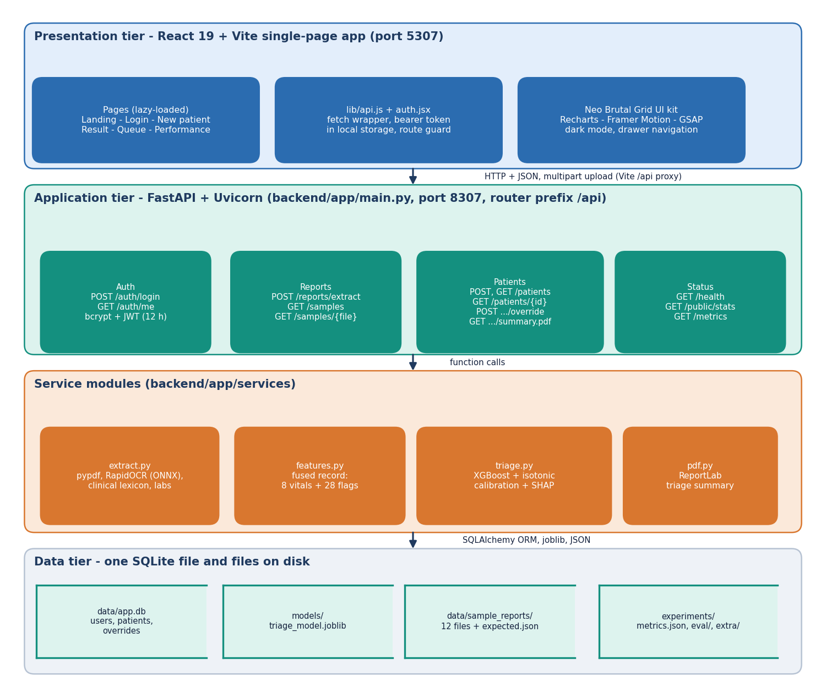
Figure 1: Three-tier architecture of ATHENA (React application, FastAPI services, SQLite and model files).
The presentation tier is a React 19 and Vite single-page application on port 5307; it reaches the API through a Vite proxy on the path /api. The application tier is FastAPI on port 8307. Its router (routes/api.py) calls four services: extract.py reads a report, features.py defines and builds the fused record, triage.py runs the calibrated XGBoost model and the SHAP explainer, and pdf.py renders the triage summary with ReportLab. Authentication (auth.py) issues and checks signed tokens. The data tier is a SQLite database (data/app.db) with three tables, plus the trained model file models/triage_model.joblib and the evaluation reports in experiments/.
The services do not import each other except through features.py, which is the single definition of the 36 model inputs. The model is trained offline by ml/train.py, so serving needs only the saved file, and the experiments in Chapter 8 can time each service on its own and together.

1.2 High-Level Workflow
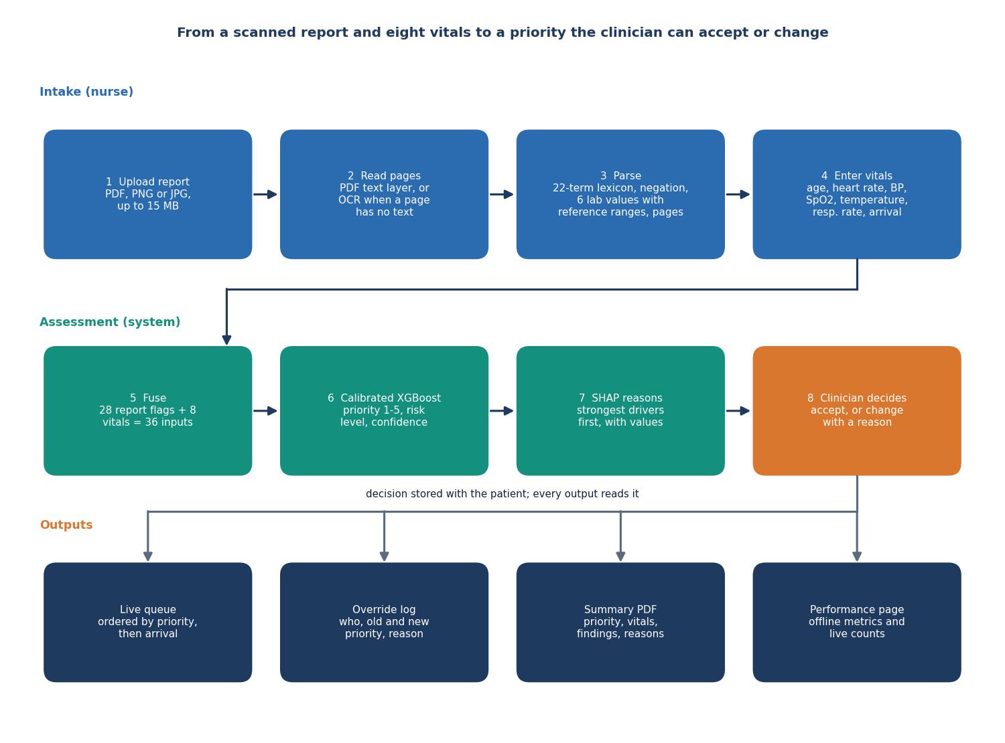
Figure 2: Workflow from a scanned report and vitals to a clinician-approved priority.
A nurse signs in, opens New patient, and uploads a PDF or an image of the report (or picks one of the twelve generated sample reports). The server reads the report and returns symptoms, findings, history and lab values, each with the page it came from. The nurse enters eight vitals. The server fuses the 28 report flags and the vitals into 36 inputs, the model returns a priority from 1 to 5 with a calibrated confidence, and SHAP lists the strongest factors. The patient is stored and the queue, which is ordered by priority and then by arrival time, is updated. A clinician opens the result and either accepts the priority or changes it with a reason; the decision is stored with the patient and the model's original suggestion is kept.
Every step runs in the same request cycle as the screen that triggers it. Reading a PDF takes about 9 ms and an image scan about 2.2 s on the CPU of the measurement machine; assigning a priority takes about 22 ms (medians over HTTP, Chapter 8).

1.3 Data Flow Diagrams

1.3.1 Level 0
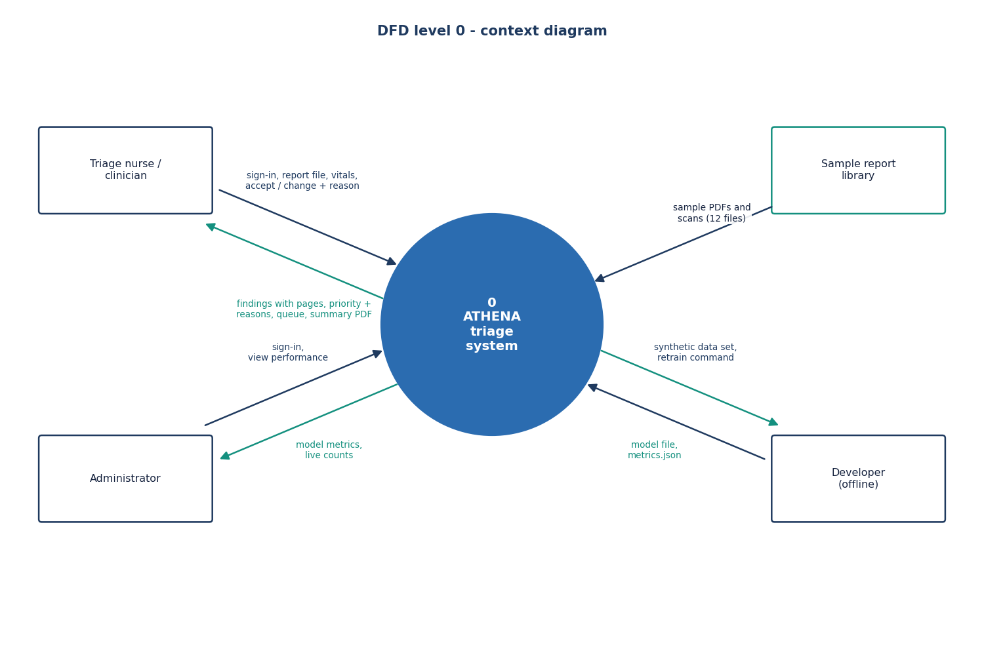
Figure 3: Data flow diagram, level 0 (context).
At the context level ATHENA is one process with three neighbours. The triage nurse provides a report file, the vitals and a sign-in, and receives the extracted findings, the priority with its reasons and the queue. The clinician provides a decision (accept or change, with a reason) and receives the patient record and a summary PDF. The administrator reads the performance figures. Training data enters only offline, when the model is built.

1.3.2 Level 1
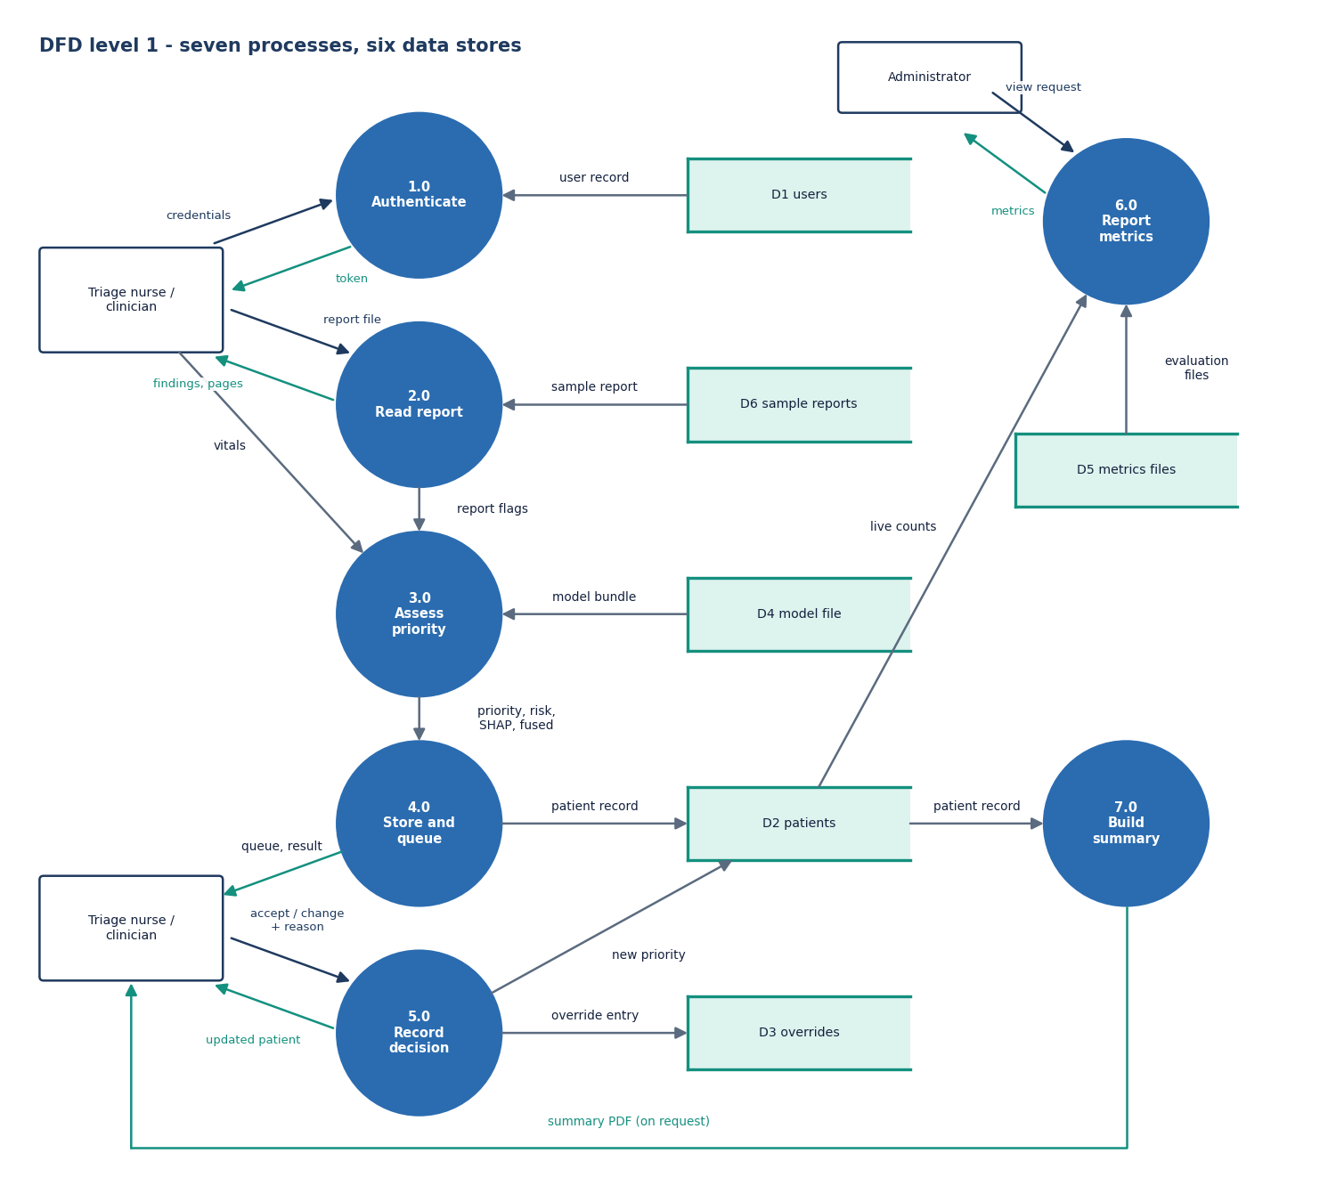
Figure 4: Data flow diagram, level 1.
Level 1 shows the main processes: authentication, report reading, fusion and triage, queue management, clinician review, summary generation and metrics. The database holds the users, patients and overrides; the model file is read by the triage process; the evaluation reports are read by the metrics process. Review writes an override and updates the patient's current priority, which the queue process then uses for its ordering.

1.3.3 Level 2
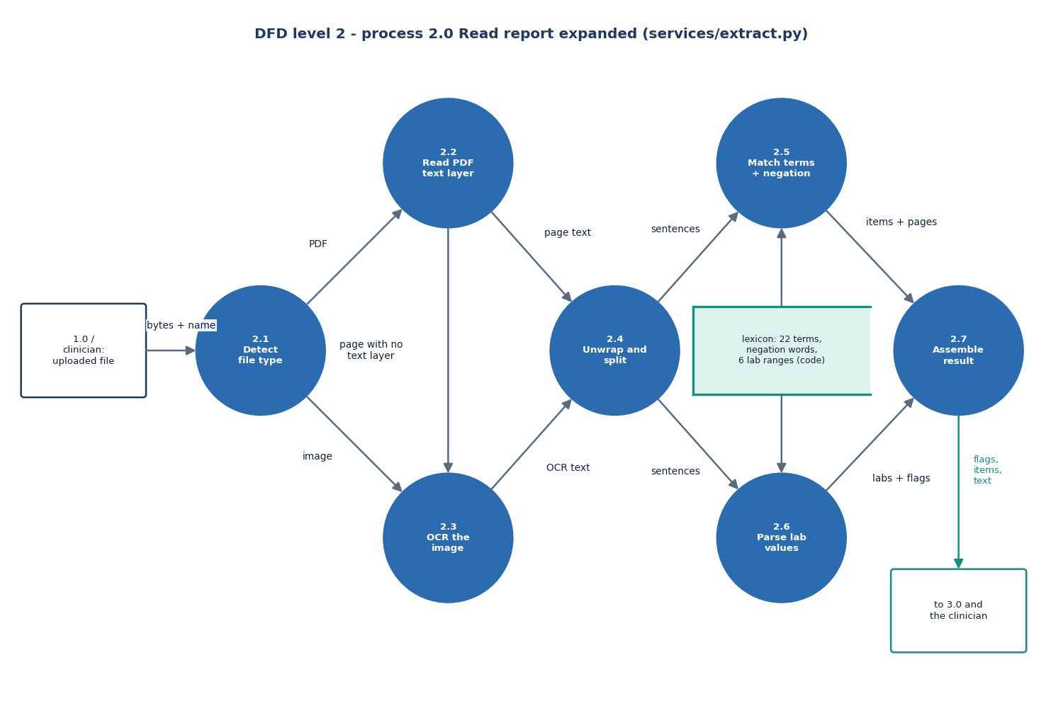
Figure 5: Data flow diagram, level 2, of report reading and triage.
The second level follows one report through the system. Page text is read (text layer or OCR), wrapped lines are re-joined and split into sentences, each sentence is matched against the clinical lexicon and the lab patterns, matches preceded by a negation are dropped, and the surviving items become the 28 report flags. The fusion step adds the eight vitals, the model gives calibrated probabilities, the priority is their arg-max, and the explainer returns the attributions for that priority.

1.4 UML Design

1.4.1 Class Diagram
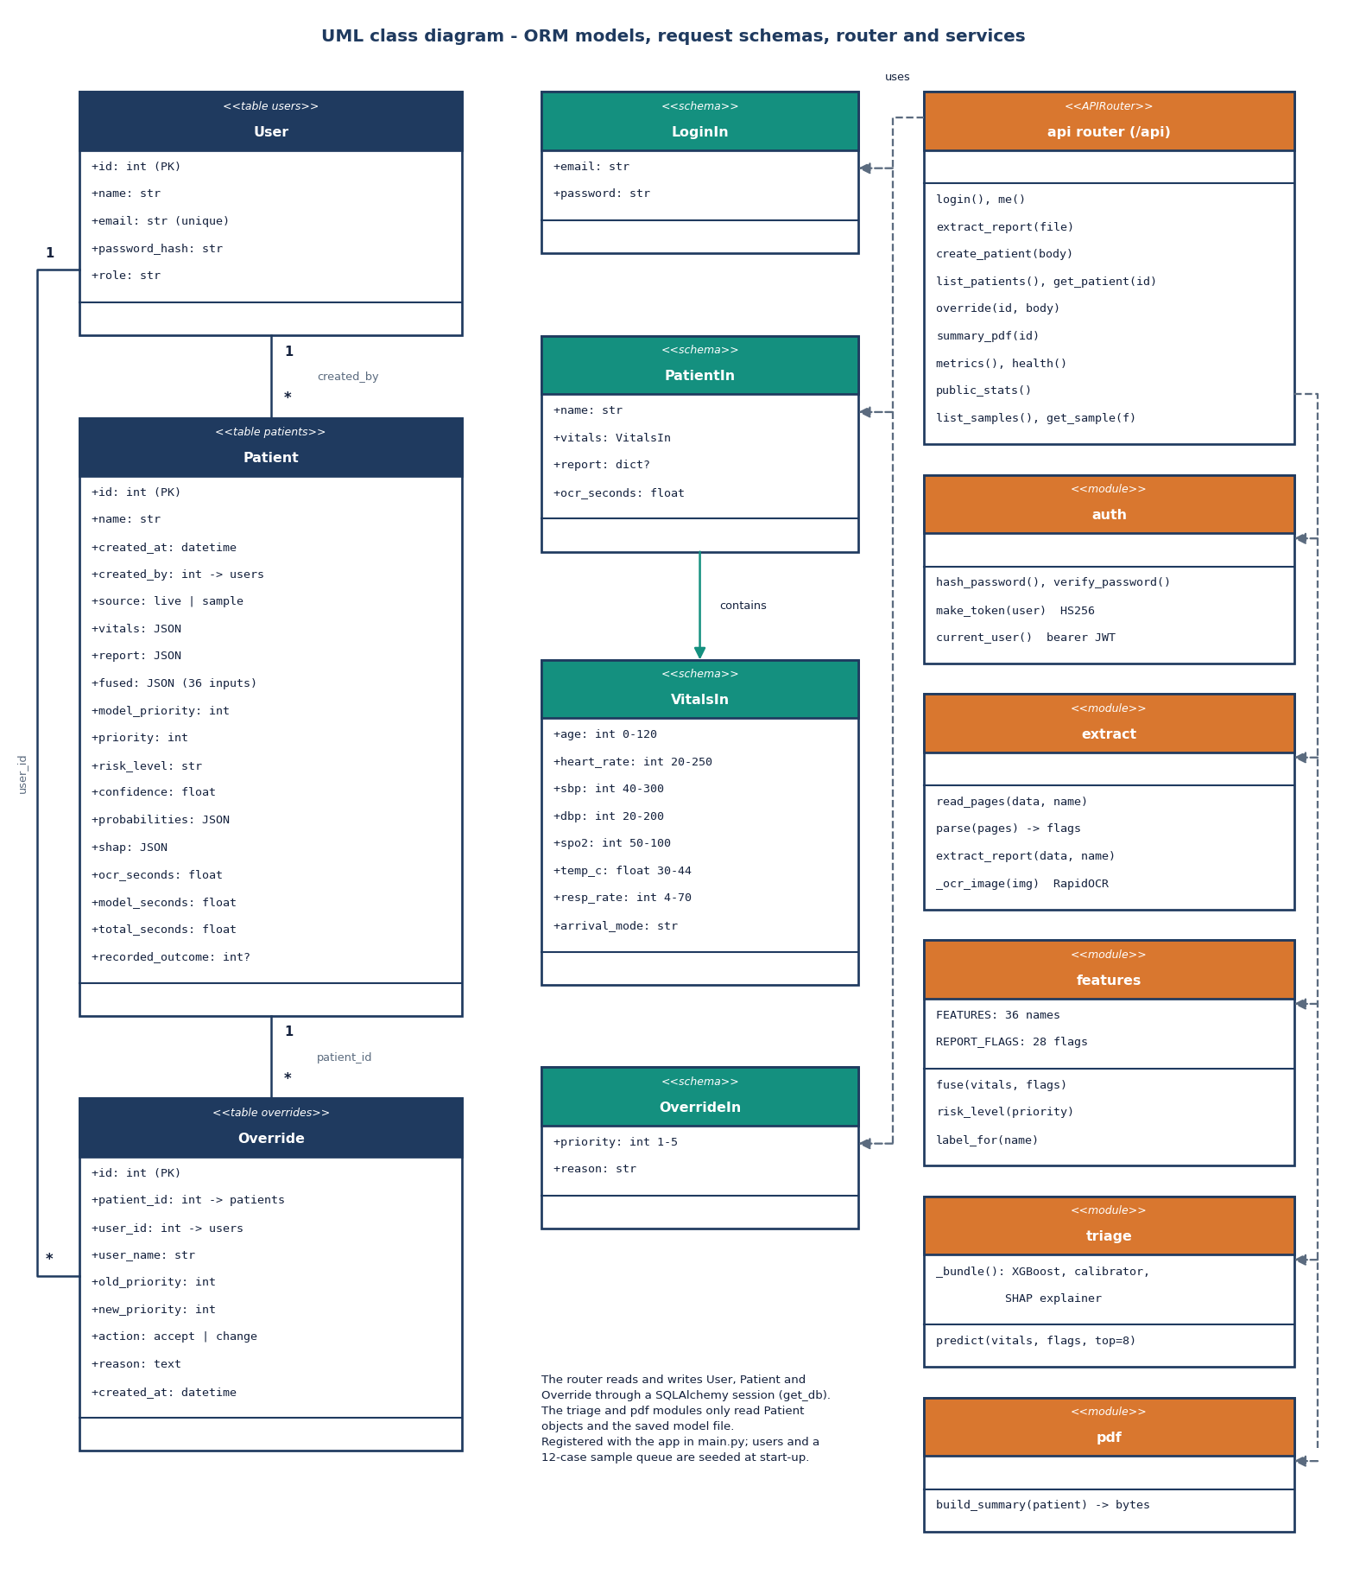
Figure 6: UML class diagram of the data model and services.
Three persistent classes carry the data: User (name, e-mail, password hash, role), Patient (vitals, report, fused record, model priority, current priority, risk level, confidence, probabilities, SHAP list and timings) and Override (the old and new priority, the action, the reason and who made it). The Pydantic classes LoginIn, VitalsIn, PatientIn and OverrideIn validate every request; for example VitalsIn limits SpO2 to 50-100 and heart rate to 20-250. The services are modules of functions, not classes: extract.parse and extract.extract_report, features.fuse, triage.predict and pdf.build_summary.

1.4.2 Sequence Diagram
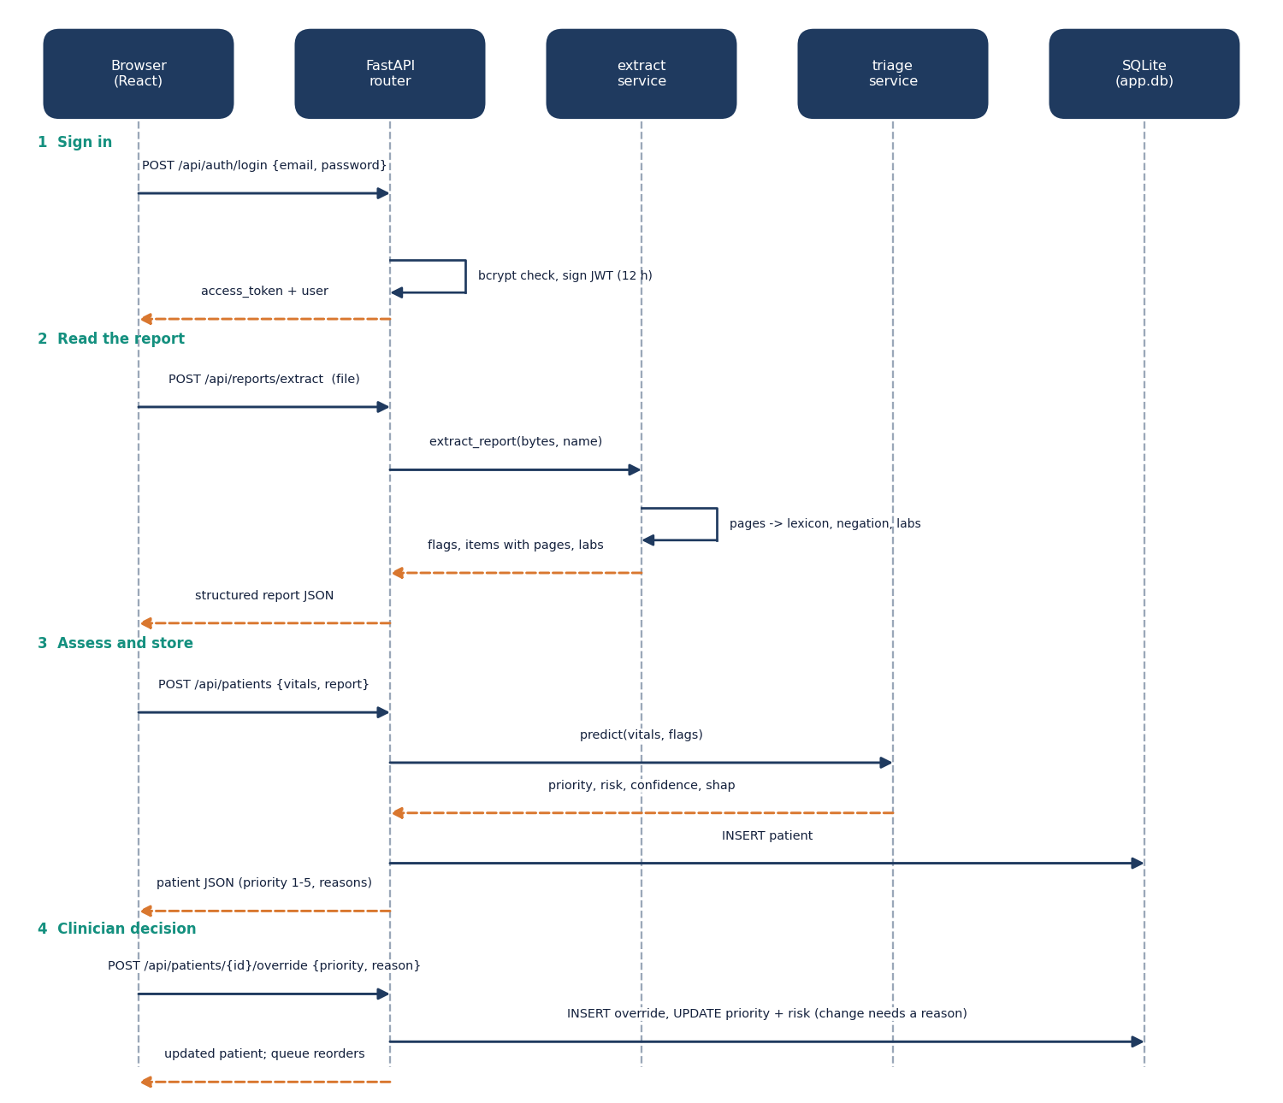
Figure 7: Sequence diagram from report upload to clinician override.
The sequence follows the main flow. The browser uploads the file to /api/reports/extract and receives the structured report. It then posts the vitals and the report flags to /api/patients; the server fuses them, calls the model, stores the patient and returns the full record. When the clinician decides, the browser posts to /api/patients/{id}/override; the server validates that a change carries a reason, writes an override row, updates the patient and returns the new record.

1.4.3 Use-Case Diagram
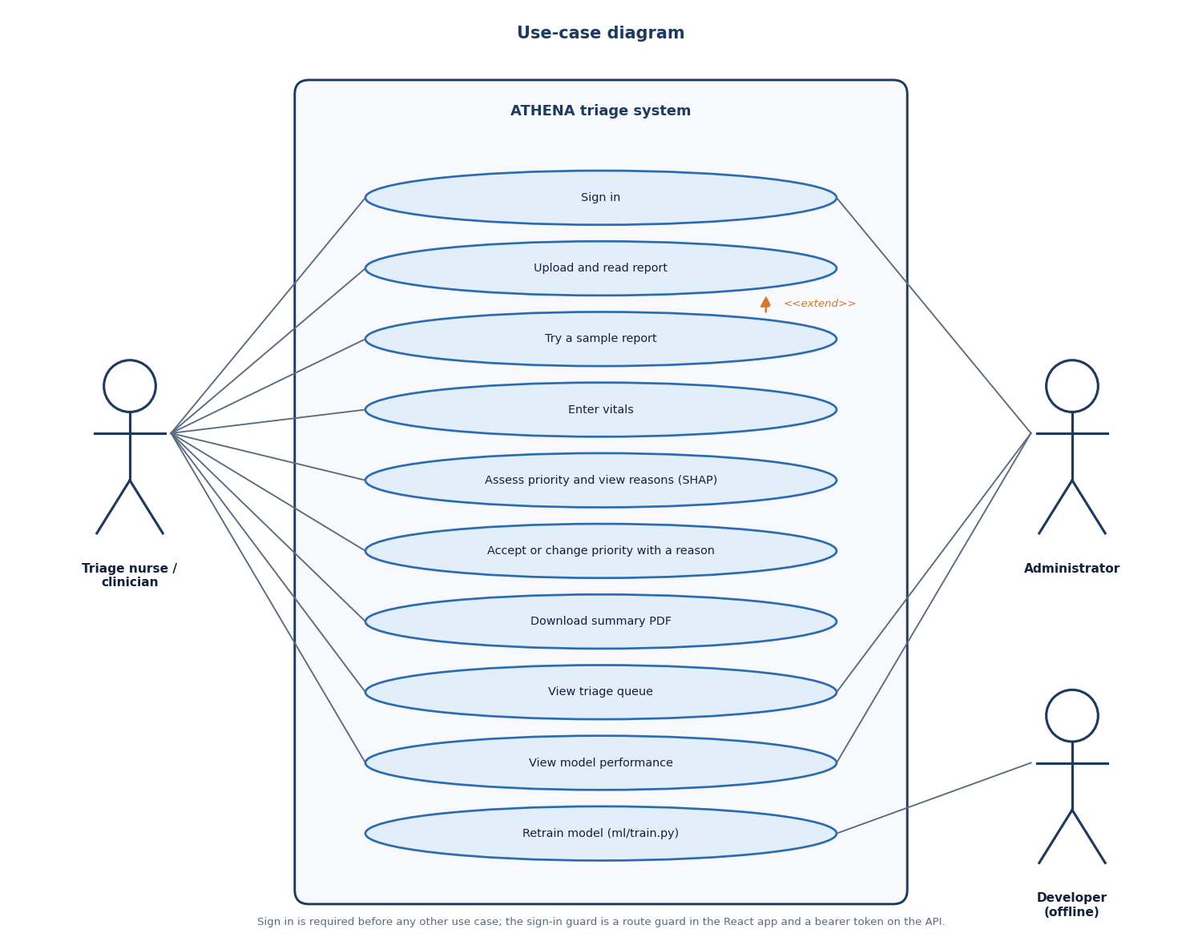
Figure 8: Use-case diagram.
The nurse uses report intake, vitals entry and the queue; the clinician uses the result screen, the decision and the summary PDF; the administrator uses the performance page. Retraining the model is a command-line action of the developer and has no screen.

1.5 Data Design
ATHENA stores its data in SQLite through SQLAlchemy. The schema has three tables. Patient fields that are structured but variable (vitals, report, fused record, probabilities and the SHAP list) are kept as JSON columns, because they are always read and written together with the patient and never filtered on.
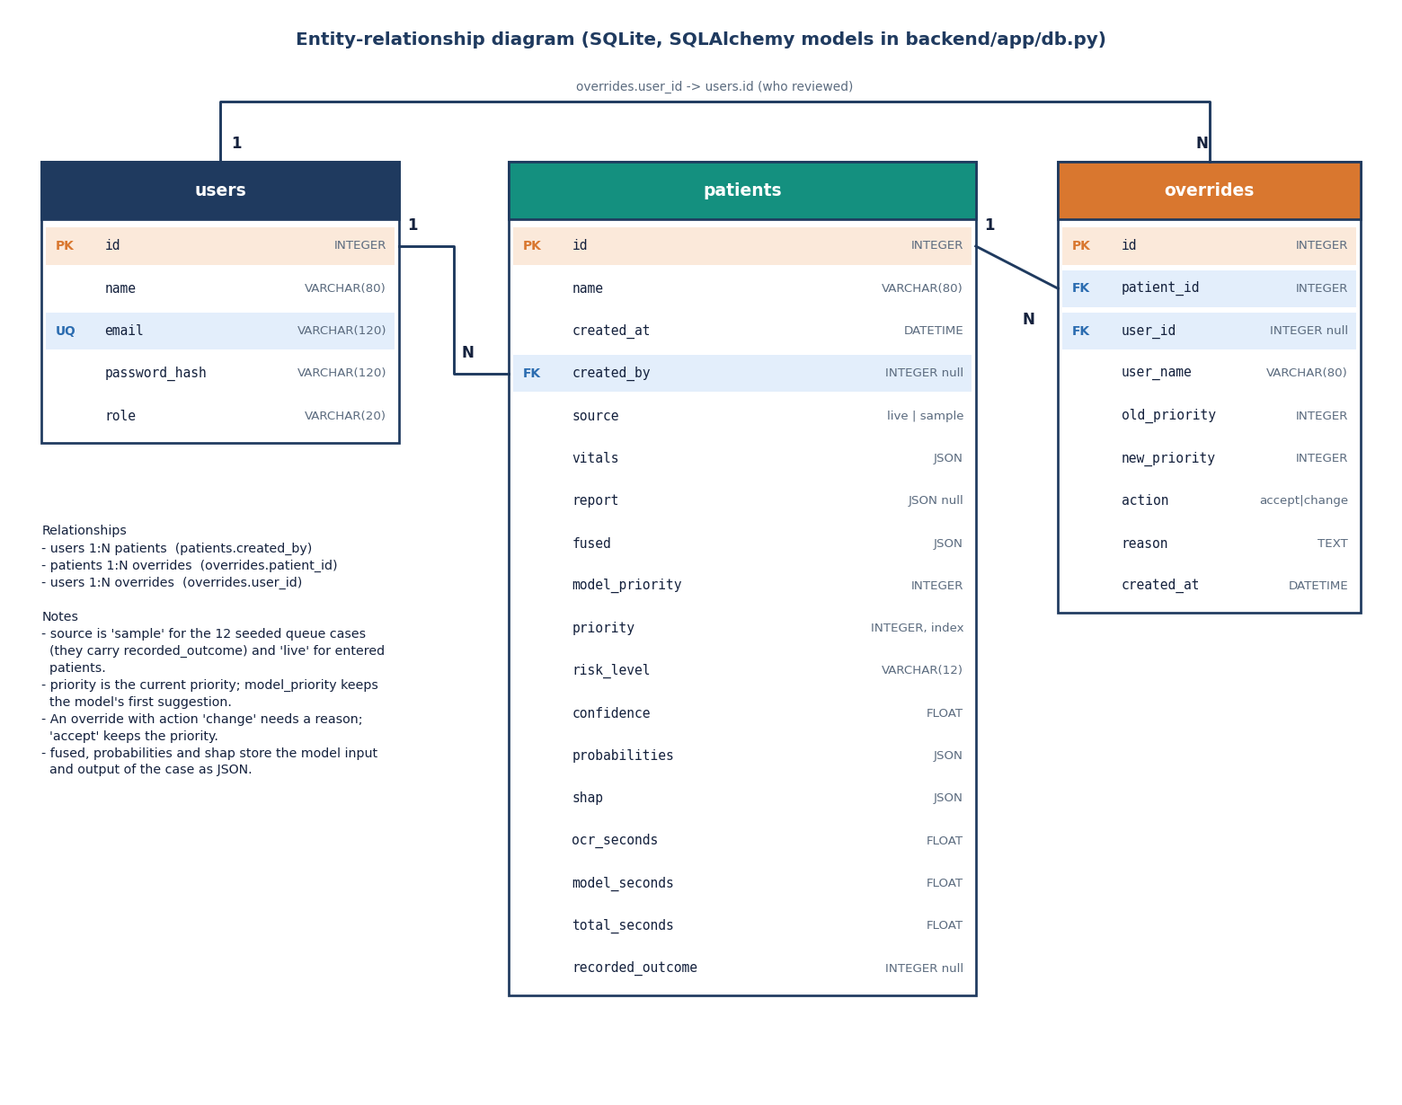
Figure 9: Entity-relationship diagram of the ATHENA database.
Table 2: Database tables and their columns
Table | Columns | Notes
users | id, name, email (unique, indexed), password_hash, role | roles: clinician, admin; passwords stored as bcrypt hashes; two demo users seeded
patients | id, name, created_at, created_by (FK users), source, vitals (JSON), report (JSON), fused (JSON), model_priority, priority (indexed), risk_level, confidence, probabilities (JSON), shap (JSON), ocr_seconds, model_seconds, total_seconds, recorded_outcome | source is live or sample; priority is the current value after any override, model_priority is never changed; recorded_outcome is set only on sample cases
overrides | id, patient_id (FK, indexed), user_id (FK), user_name, old_priority, new_priority, action, reason, created_at | action is accept or change; reason required for a change

A user has many patients (through created_by) and many overrides; a patient has many overrides, ordered by id. A new database is seeded with the two demo users and twelve sample cases built from rows of data/sample/holdout_sample.csv; they carry source = sample and a recorded_outcome, so the queue and the performance page are not empty on the first run and sample cases are always labelled as such in the interface.
Table 3: Other data structures
Structure | Content | Lives in
Fused record | 36 numbers in model column order: 8 vitals and 28 report flags | built per request, stored with the patient
Report flags | 28 flags: 11 symptom, 5 finding, 6 history, 6 lab | features.REPORT_FLAGS
Model bundle | XGBoost base model, isotonic-calibrated wrapper and the feature list | models/triage_model.joblib
Evaluation reports | held-out metrics, confusion matrix, reading and timing results | experiments/metrics.json, experiments/eval/metrics.json
Sample reports | 8 PDFs and 4 PNG scans with the expected flags and vitals | data/sample_reports/

1.6 Algorithm Design

1.6.1 Report reading
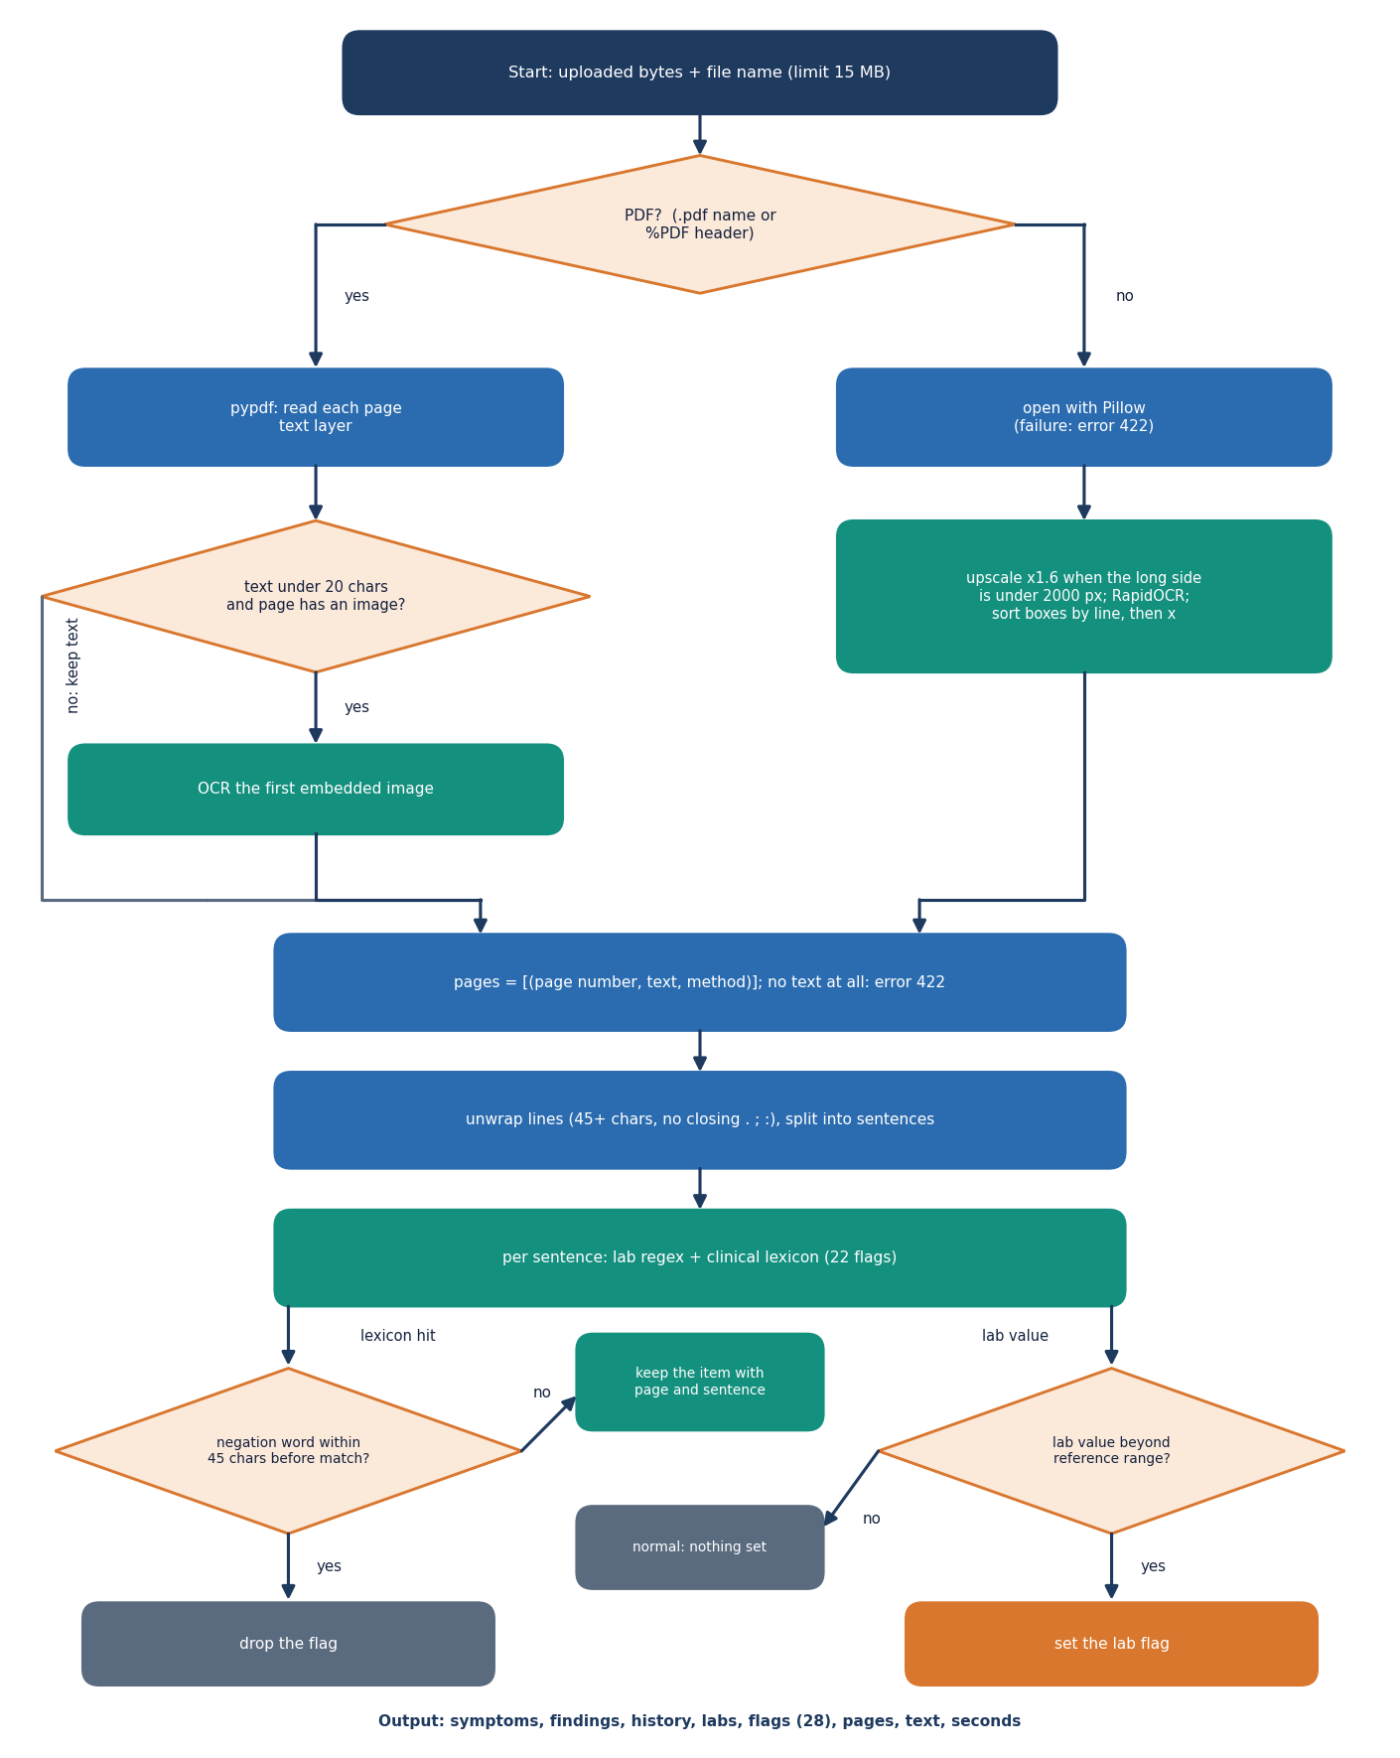
Figure 10: Flowchart of report reading.
A PDF page is read with its text layer; a page with fewer than 20 characters of text is treated as a scan and its first embedded image goes to OCR. An image upload goes straight to OCR. The OCR engine is RapidOCR, which runs PaddleOCR-family detection and recognition models on ONNX Runtime and needs no network [23]; the image is enlarged by a factor of 1.6 when its longer side is under 2,000 pixels, and the recognised boxes are put in reading order by line. Wrapped lines are joined, the text is split into sentences, and each sentence is tested against a lexicon of 22 regular expressions for symptoms, findings and history. Spaces inside a phrase match zero or more whitespace characters, so a run-on such as "shortnessofbreath" still matches. A match is dropped when one of the words no, denies, denied, without, negative for, absence of, not, nil, free of, ruled out occurs within 45 characters before it in the same sentence. Six lab values (troponin, lactate, white cell count, glucose, creatinine, haemoglobin) are read with their value and compared with a reference limit; an abnormal value sets the lab flag. Every item keeps the page it was found on.

1.6.2 Triage scoring
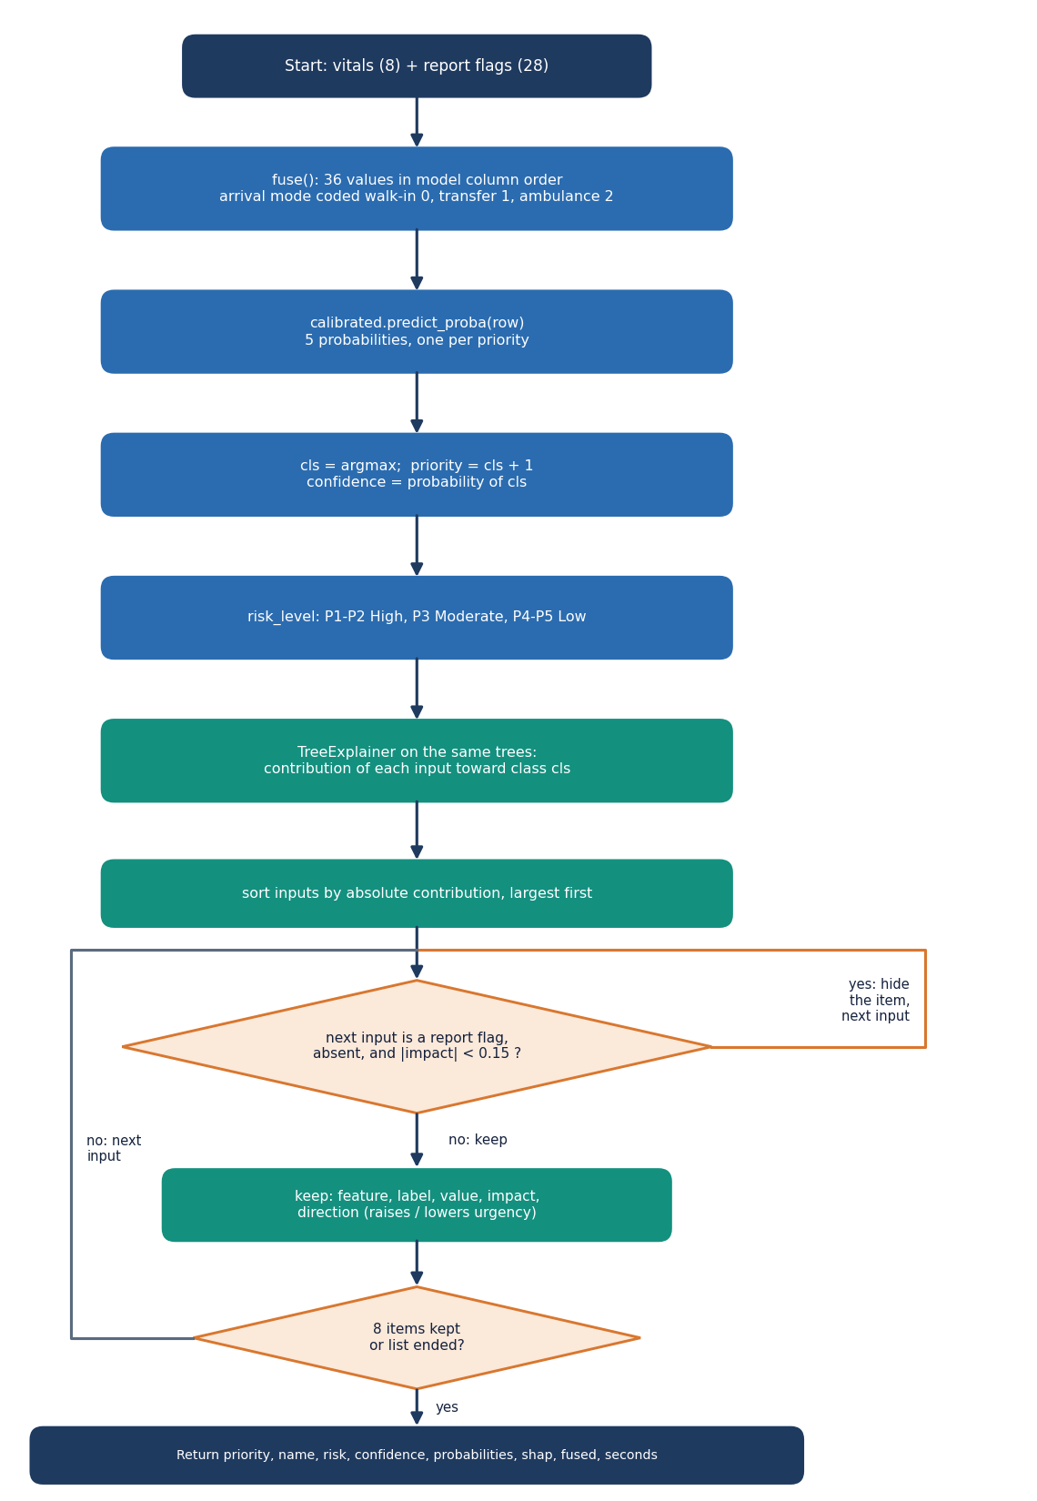
Figure 11: Flowchart of triage scoring and the clinician decision.
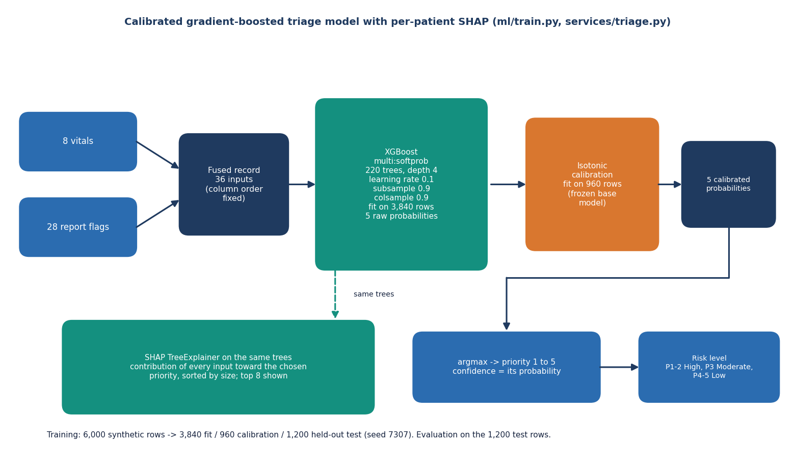
Figure 12: Architecture of the triage model (fusion, XGBoost, calibration, SHAP).
features.fuse builds a dictionary in the fixed column order: the eight vitals (arrival mode coded walk-in 0, transfer 1, ambulance 2) followed by the 28 flags, each 0 or 1. A flag that the report does not mention is 0, which is the same rule the base paper applies to symptoms that were not documented [1]. The model is an XGBoost classifier [15] with 220 trees of depth 4 that returns five scores; an isotonic calibrator fitted on a separate split turns them into probabilities [18], and the priority is the class with the largest probability. The risk level is High for priorities 1 and 2, Moderate for 3 and Low for 4 and 5. SHAP's tree explainer [17] then gives the contribution of each of the 36 inputs towards the chosen priority; the list is sorted by absolute value, absent flags with a contribution below 0.15 are hidden, and the top eight are returned.
On the synthetic hold-out the factors with the largest mean absolute SHAP value over all five classes are SpO2 (0.42), arrival mode (0.32), shortness of breath (0.27), systolic blood pressure (0.24) and respiratory rate (0.23). This matches the weights used to build the synthetic labels, so it checks that the explainer reads the model correctly; it says nothing about clinical importance.

1.7 Module Design
Table 4: Modules, responsibilities and size
Module / file | Responsibility | Lines
backend/app/main.py | FastAPI application, start-up (create tables, warm the model and OCR engine, seed users and the sample queue), CORS | 84
backend/app/routes/api.py | 13 routes, request schemas, serialisation, queue ordering, override rules, metrics | 225
backend/app/db.py | SQLAlchemy engine, session factory and the three models | 79
backend/app/auth.py | bcrypt hashing, HS256 token creation and checking, current-user dependency | 47
backend/app/services/extract.py | PDF text, OCR, lexicon, negation, lab parsing | 187
backend/app/services/features.py | vital and flag definitions, labels, arrival codes, risk level, fuse | 87
backend/app/services/triage.py | model loading, calibrated prediction, SHAP attribution | 73
backend/app/services/pdf.py | triage summary PDF (ReportLab) | 63
ml/make_data.py, ml/train.py, ml/eval.py | synthetic dataset, training and calibration, evaluation of reading and timing | 108 / 74 / 59
frontend/src/ | 31 files: 6 pages, a design kit of UI components, API client, auth, theme and storage helpers | about 3,400
scripts/ and tests/ | sample reports, smoke test, screenshots, responsive check, experiments, API timing; 47 pytest tests | see Chapter 7

The modules are small and each has one reason to change. features.py is the single source of the column order that triage.py, make_data.py, train.py and the tests import, so the schema cannot drift between training and serving. routes/api.py is the only module that touches HTTP.

1.8 API Design
The API is JSON over HTTP under the prefix /api, plus one multipart upload route and one PDF download. All routes except health, public/stats and auth/login need a bearer token. The routes fall into five groups; request and response details are in Chapter 6.
Table 5: API route groups
Group | Routes | Purpose
Service | GET /health, GET /public/stats | liveness and model presence; headline numbers for the landing page
Authentication | POST /auth/login, GET /auth/me | sign in, who am I
Report intake | POST /reports/extract, GET /samples, GET /samples/{file} | read an upload; list and fetch the generated sample reports
Patients | POST /patients, GET /patients, GET /patients/{id}, GET /patients/{id}/summary.pdf, POST /patients/{id}/override | triage, queue, record, summary, decision
Evaluation | GET /metrics | offline evaluation and live counts

Validation is strict and returns a meaningful status instead of a stack trace: an empty upload is 400, an upload over 15 MB is 413, an unreadable file is 422, vitals outside their physical limits are 422, a missing patient is 404, and a missing or expired token is 401. A model that is not trained returns 503.

1.9 User Interface Design
The interface is a React single-page application built on the shared Neo Brutal Grid design kit: hard-edged boxes with a 3-pixel border and offset shadow, flat colour with no gradients, an Archivo Black display face with IBM Plex Sans and Mono for text, and one fixed colour for each priority (1 coral, 2 amber, 3 sky, 4 lime, 5 paper). A dark theme, reduced-motion support, a drawer navigation on narrow screens and visible keyboard focus are provided. The token is kept in the browser's local storage, and any 401 response signs the user out.
Table 6: Application screens
Route | Screen | What the user does
/ | Landing | reads what ATHENA does and the headline evaluation numbers, marked as synthetic
/login | Sign in | enters credentials or uses a demo button
/app/new | New patient | uploads or picks a report, reviews what was found (with pages), enters the vitals and assigns a priority
/app/patients/:id | Result | sees priority, risk and confidence, the fused record, the SHAP bars and probabilities; accepts or changes the priority; downloads the PDF
/app/queue | Triage queue | sees patients sickest first, filters by priority tab or search; the list refreshes every 15 seconds
/app/performance | Model performance | reads accuracy, per-priority recall, the confusion matrix, seconds per patient and the live review counts

• Every screen that shows model output carries the notice that the evaluation is on a seeded synthetic dataset.
• The result screen shows the report-derived and the vitals-derived halves of the fused record side by side, so a clinician can see what the model was given.
• Errors from the API are shown as messages with a retry action and never as blank screens; sample cases are labelled as samples in the queue.

1.10 Key Design Decisions
Table 7: Decisions and their reasons
Decision | Reason | Consequence
Local OCR (RapidOCR) and a clinical lexicon instead of a cloud multimodal model | no network, no API key, no patient text leaving the machine | reading is rule-based: 100% on the generated samples but recall 84.3% on the hand-written stress set
Fuse 28 report flags with 8 vitals in one table of 36 inputs | one model sees both sources; flags are interpretable | a missed flag is a 0, so reading errors reach the model
XGBoost with isotonic calibration and a tree explainer | calibrated probabilities and exact tree SHAP at millisecond cost; room for non-linearity on real data | on the synthetic data logistic regression scored higher (72.4% against 68.2%)
Five-level priority as the target | matches the clinical scale and the batch objective | ordinal errors matter: within-one accuracy is reported next to exact accuracy
Priority and model suggestion stored separately | overrides become feedback and agreement can be measured | the live agreement rate needs real use to mean anything
SQLite with JSON columns | no database server; the demo runs from one folder | single-writer; not a multi-site design
Synthetic training data | no real patient records were available | all accuracy figures describe a simulated rule, not clinical performance

1.11 Security and Error-Handling Design
The security design is described against a simple threat model and the limits of that model are stated. The system is meant for a trusted ward network. Against a user without credentials it provides authentication on every patient route, bcrypt password hashes, signed tokens that expire after 12 hours, a path check on the sample-file route, a 15 MB upload limit and range validation on every vital. Database access goes through the ORM, so request values are never concatenated into SQL.
Table 8: Controls and their limits
Control | What it does | Limit
Bearer token (HS256, 12 h) | protects every patient, queue and metrics route | default secret dev-secret-change-me when JWT_SECRET is unset; no refresh or revocation
bcrypt password hashes | no plain passwords in the database | two demo accounts with a published password
Role field (clinician, admin) | stored with the user and the token | routes do not yet check the role: any signed-in user can do everything
Pydantic validation | age, heart rate, blood pressure, SpO2, temperature and respiratory rate within physical limits | limits are plausible bounds, not clinical alarms
Upload limits | 15 MB, PDF / PNG / JPG only, empty file refused | no virus scanning; no rate limiting
CORS fixed to the two local origins | browsers from other origins are refused | plain HTTP; no TLS
Override audit | who, when, old and new priority, action and reason are stored | no tamper-proofing of the log; the database is a single file

Errors follow one rule: a failure is reported with a status code and a short message the user can act on, and the server keeps running. If the model file is missing, scoring routes answer 503 with the instruction to train; at start-up a missing model only skips the warm-up and the sample queue. The browser shows API messages in the interface and turns a lost connection into a single Cannot reach the ATHENA API message.
None of this makes the system safe for real patients. There is no HTTPS, no rate limiting, no role enforcement, no audit beyond overrides and no regulatory review, and the model has never seen a real patient record. ATHENA is a decision-support prototype; the treating clinician makes the final triage decision.

2. IMPLEMENTATION

2.1 Application architecture
ATHENA is two processes behind a browser. The browser tier is a React 19 single-page application built with Vite on port 5307; its API client (lib/api.js) adds the bearer token to every request and turns failures into a typed error with the server's message. The application tier is a FastAPI application (backend/app/main.py) served by Uvicorn on port 8307. At start-up it creates the tables, runs one prediction to warm the model and the SHAP explainer (the first call is otherwise noticeably slow), loads the OCR engine in a background thread, seeds the two demo users and, if the patients table is empty, twelve labelled sample cases.
Table 9: Modules and their responsibilities
Module | Responsibility
backend/app/main.py | application factory, start-up warm-up, user and sample-queue seeding, CORS for the two local origins
backend/app/routes/api.py | all 13 routes, request schemas, patient serialisation, queue ordering, override rules, metrics aggregation
backend/app/db.py | SQLAlchemy engine (SQLite, DATABASE_URL overridable), session dependency, User, Patient and Override models
backend/app/auth.py | bcrypt hashing, HS256 token creation and checking, current_user dependency
backend/app/services/extract.py | PDF text, OCR, sentence splitting, lexicon and negation, lab parsing, per-page items
backend/app/services/features.py | the 36-input definition, labels, arrival codes, priority names, risk level, fuse
backend/app/services/triage.py | cached model bundle, calibrated prediction, SHAP attribution and display values
backend/app/services/pdf.py | triage summary PDF with ReportLab
ml/ | make_data.py (dataset), train.py (model and metrics), eval.py (reading and end-to-end timing)
frontend/src/ | pages (Landing, Login, NewPatient, PatientResult, Queue, Performance), the design-kit components, auth and theme
scripts/ and tests/ | sample reports, smoke test, screenshots, responsive check, experiments, timing, stress test; 47 pytest tests

State lives in three places. The model file models/triage_model.joblib and the evaluation reports are read when needed; the SQLite file data/app.db holds users, patients and overrides; the browser keeps only the token and the theme in local storage. The model bundle and the SHAP explainer are cached in memory after their first use. Nothing else is kept between requests, so the API can be restarted at any time without losing a patient.
Figure 13: Layered architecture of ATHENA.

2.2 API design
The API is JSON over HTTP, plus one multipart upload and one PDF download. The table lists every route with its request, its successful response and its errors.
Table 10: API routes of ATHENA (all under /api)
Method and path | Request | Success response | Errors
GET /health | - | status, model present | -
GET /public/stats | - | data note, accuracy, within-one, macro F1, n_test, model seconds | -
POST /auth/login | email, password | access_token, user (id, name, email, role) | 401 wrong credentials
GET /auth/me | token | current user | 401
GET /samples | token | items: filename, vitals, kind (pdf or image) | 401
GET /samples/{file} | token | the generated sample file (PDF or PNG) | 404 unknown or outside the folder
POST /reports/extract | multipart file, at most 15 MB | symptoms, findings, history, labs (each with page), flags (28), pages, text, seconds | 400 empty, 413 too large, 422 unreadable
POST /patients | name, vitals (8 fields), report flags, ocr_seconds | patient: priority, risk, confidence, probabilities, SHAP list, fused record, timings | 422 invalid vitals or arrival mode, 503 no model
GET /patients | token | queue items ordered by priority then arrival, with top three drivers | 401
GET /patients/{id} | token | full record with overrides | 404
GET /patients/{id}/summary.pdf | token | triage summary (application/pdf) | 404
POST /patients/{id}/override | priority 1-5, reason | updated patient with the new override | 404, 422 change without a reason or priority out of range
GET /metrics | token | offline metrics and live counts (patients, reviews, changes, agreement rate, mean seconds, distribution) | 401

The extract route only reads the file and returns what it found; nothing is stored, so a nurse can inspect the reading before committing a patient. The patients route takes the flags from the report object and ignores anything else in it, builds the fused record, calls the model and stores the patient with its timings: the OCR time sent by the browser, the model time and the total. The override route decides between accept (the posted priority equals the current one) and change (it does not), requires a reason for a change, writes an override row with the user's name, replaces the patient's current priority, recomputes the risk level and leaves model_priority untouched, which is what lets the performance page report how often clinicians kept the model's suggestion.
The queue route returns every patient ordered by current priority and then by arrival time. The metrics route combines the stored offline evaluation with live counts: patients, reviews, changed priorities, the agreement rate (one minus the share of reviewed patients whose priority was changed), the mean seconds per live patient and, for the sample cases that carry a recorded priority, the share the model matched.

2.3 Security and error handling

2.3.1 What the design protects
• Access. Every patient, queue, report and metrics route requires a signed bearer token (HS256, valid for 12 hours); passwords are stored as bcrypt hashes; a 401 from the API signs the user out in the browser.
• Input. Vitals are range-checked by Pydantic, the arrival mode must be one of three values, uploads are limited to 15 MB and refused when empty or unreadable, and the sample-file route checks that the resolved path is inside the samples folder and has a PDF or PNG suffix.
• Database. All queries go through the SQLAlchemy ORM; no request value is placed in SQL text.
• Accountability. Each decision is stored with the user, time, old and new priority, action and reason, and the model's own suggestion is never overwritten.
• Failures. Errors are returned with a status code and a short message; a missing model gives 503 and a start-up warning instead of a crash.

2.3.2 What it does not protect
• Default secret. When JWT_SECRET is not set the token key is the literal dev-secret-change-me (PyJWT warns that it is shorter than 32 bytes), so tokens can be forged by anyone who reads the source.
• Roles. The user's role is stored and put in the token, but no route checks it: a clinician can call every route an administrator can.
• Transport and abuse. The service speaks plain HTTP, has no rate limiting and no account lock-out, and the two demo accounts have a published password.
• Data protection. Patient data is stored unencrypted in one SQLite file; there is no retention policy, no export or erase function and no review against a health-data regulation.
• The model. The classifier has seen only synthetic data, the reader misses some wording, and nothing in the product stops a user from ignoring a High-risk result. It is decision support for a clinician who stays responsible.
Table 11: Error handling in the API
Situation | Response | Where
Missing or invalid token | 401 with a message; the browser clears the token and shows the sign-in page | current_user
Wrong e-mail or password | 401 "Email or password is wrong." | login route
Empty upload / larger than 15 MB / not a readable document | 400 / 413 / 422 with the reason | extract route
Vitals outside physical limits or unknown arrival mode | 422 with the field and limit | Pydantic, patients route
Priority change without a reason | 422 "Give a reason when changing the priority." | override route
Unknown patient or sample | 404 | patient and sample routes
Model file missing | 503 "Model not trained yet"; warm-up and seeding skipped with a log warning | triage._bundle, start-up
API unreachable from the browser | single message "Cannot reach the ATHENA API" | lib/api.js

2.4 Installation and execution
The full step-by-step guide is Appendix B and docs/03_HOW_TO_RUN.md. The product runs in two ways.
1. run.bat (Windows). Checks the environment and, if needed, runs setup.bat: it creates the venv/ Python environment and installs requirements.txt, generates the synthetic dataset and trains the model when models/triage_model.joblib is missing, generates the sample reports when missing, and runs npm install in frontend/. It then starts the API and the web application in two minimised windows and opens http://localhost:5307.
2. Manual. python -m uvicorn backend.app.main:app --port 8307 from 8.ProjectCode, and npm run dev in frontend/; the Vite server proxies /api to the API.
venv\Scripts\python ml\make_data.py # seeded synthetic dataset -> data\sample\
venv\Scripts\python ml\train.py # model -> models\, metrics -> experiments\metrics.json
venv\Scripts\python ml\eval.py # reading and timing -> experiments\eval\metrics.json
venv\Scripts\python scripts\smoke_test.py # 17 checks against the running API
venv\Scripts\python -m pytest tests # 47 tests

Ports are fixed: API 8307, web 5307. An optional .env may set DATABASE_URL and JWT_SECRET; otherwise a local SQLite file and the development secret are used. Sign in with clinician@athena.health and the demo password given in Appendix B. A new database starts with twelve labelled sample cases so that the queue and the performance page are not empty. Deleting data/app.db resets the queue and the review log.
Verification after installation is python -m pytest tests (47 tests: 46 pass and 1 documented expected failure, about 15 seconds) and scripts/smoke_test.py (17 of 17 checks pass), described in Chapter 7. scripts/capture_screens.py regenerates the screenshots used in Chapters 7 and 8. The fresh-environment path of setup.bat and scripts/download_data.py were not exercised in the documentation run.

3. KEY CODE WALK-THROUGHS
This section walks through the code that carries the design. The listings are copied from the repository at the state in which the results were measured.

3.1 Reading a sentence: lexicon match and negation
NEGATION = re.compile(r"\b(no|denies|denied|without|negative for|absence of|not|nil|free of|ruled out)\b[^.;\n]{0,45}$", re.I)

for flag, rx in COMPILED.items():
if flag in items:
continue
m = None
for cand in rx.finditer(sent):
# a brain bleed is the finding "ct_hemorrhage", not the symptom "bleeding"
if flag == "bleeding" and re.search(r"(intracranial|subarachnoid|cerebral|subdural)\s*$", sent[: cand.start()], re.I):
continue
m = cand
break
if not m:
continue
if NEGATION.search(sent[: m.start()]):
continue

NEGATION matches a negating word followed by at most 45 characters up to the end of the text before the match. parse tests each of the 22 clinical flags in turn against the sentence; the first match is kept unless the text before it ends inside a negation window, in which case the flag stays 0. A brain bleed is excluded from the bleeding symptom so that it is read as the finding ct_hemorrhage. Each accepted item stores its text, its category and the page, which is how the interface shows p.1 next to a finding. The window is a deliberate simplification: it needs no parser and handles "denies chest pain" and "no fever", but it also swallows what follows "but" in the same clause, a defect the stress test records (negation precision 50%).

3.2 One patient representation
def fuse(vitals: dict, flags: dict) -> dict:
"""One patient representation: vitals plus report flags, in model column order."""
row = {}
for v in VITALS:
if v == "arrival_code":
mode = vitals.get("arrival_mode", "walk-in")
row[v] = ARRIVAL_CODES.get(mode, 0)
else:
row[v] = float(vitals[v])
for f in FLAGS:
row[f] = 1 if flags.get(f) else 0
return row

fuse builds the dictionary of 36 inputs in the exact column order of the model: eight vitals, with the arrival mode coded 0, 1 or 2 and an unknown mode defaulting to walk-in, then 28 flags set to 1 if present and 0 otherwise. Because the order is fixed in one place (FEATURES), training, inference and the explanation use the same columns, and a report that mentions nothing gives all-zero flags rather than an error.

3.3 Priority, confidence and explanation
def predict(vitals: dict, flags: dict, top: int = 8) -> dict:
t0 = time.time()
b = _bundle()
row = fuse(vitals, flags)
X = pd.DataFrame([row])[FEATURES]
proba = b["calibrated"].predict_proba(X)[0]
cls = int(np.argmax(proba))
sv = b["explainer"].shap_values(X)
# shap returns list per class or (n, features, classes) depending on version
if isinstance(sv, list):
contrib = np.asarray(sv[cls])[0]
else:
arr = np.asarray(sv)
contrib = arr[0, :, cls] if arr.ndim == 3 else arr[0]
order = np.argsort(-np.abs(contrib))
shap_items = []
for i in order:
name = FEATURES[i]
is_flag = name not in ("age", "heart_rate", "sbp", "dbp", "spo2", "temp_c", "resp_rate", "arrival_code")
if is_flag and row[name] == 0 and abs(contrib[i]) < 0.15:
continue
shap_items.append({
"feature": name, "label": label_for(name), "value": _display(name, row[name]),
"impact": round(float(contrib[i]), 4),
"direction": "raises urgency" if contrib[i] > 0 else "lowers urgency",
})
if len(shap_items) >= top:
break

The calibrated classifier returns five probabilities and the priority is the arg-max plus one. SHAP's TreeExplainer works on the underlying boosted trees and returns, for the chosen class, one contribution per input; they are sorted by absolute value. An absent flag with a negligible contribution (below 0.15) is hidden, since a long list of reasons that are not there would bury the useful ones. The function also returns the elapsed time, which feeds the performance page. The explainer's cold start is several seconds, so the application warms it when the server starts; the measured median for creating a patient over HTTP is 22 ms.

3.4 The clinician's decision
def override(pid: int, body: OverrideIn, db: Session = Depends(get_db), user: User = Depends(current_user)):
p = db.get(Patient, pid)
if not p:
raise HTTPException(404, "Patient not found.")
action = "accept" if body.priority == p.priority else "change"
if action == "change" and not body.reason.strip():
raise HTTPException(422, "Give a reason when changing the priority.")
db.add(Override(patient_id=p.id, user_id=user.id, user_name=user.name, old_priority=p.priority,
new_priority=body.priority, action=action, reason=body.reason.strip()))
p.priority = body.priority
p.risk_level = "High" if body.priority <= 2 else "Moderate" if body.priority == 3 else "Low"
db.commit()
db.refresh(p)
return patient_out(p)

The override route decides the action from the numbers: the same priority is an acceptance, a different one is a change, and a change without a reason is refused with 422. The row written to overrides keeps the old and new priority, the clinician's name and the reason; the patient's priority and risk level update while model_priority keeps the model's original suggestion, so the performance page can report how often clinicians kept it. The queue is sorted by priority and arrival time on the next request.

4. IMPLEMENTATION DECISIONS AND THEIR REASONS
Each design decision below was taken for a reason and has a cost; the table states both.
Table 12: Implementation decisions and their reasons
Decision | Chosen | Alternative | Reason and consequence
Report reading | PDF text layer first, RapidOCR only for images and image-only pages | Cloud multimodal model; BioBERT; PaddleOCR proper | Runs offline with no key or model download; PDFs are instant. Cost: a lexicon misses paraphrases (recall 14.3% on them). The Gemini path was dropped by choice.
Extraction | Regex lexicon with a 45-character negation window | Medical language model | Transparent, testable, no GPU. Cost: the defects listed under limitations; BioBERT is future work.
Representation | 36 inputs: 8 vitals + 28 flags | Embeddings of the report text | Every input has a name a clinician can read, so SHAP reasons are readable.
Model | XGBoost, 220 trees, depth 4 | Logistic regression; MLP; random forest | Fast (0.44 s training), handles interactions, supports TreeExplainer. Cost: logistic regression is at least as accurate here (72.42% against 68.25%).
Confidence | Isotonic calibration on a separate 20% split | Raw probabilities; temperature scaling | Non-parametric and standard for boosted trees. Cost: only a small gain (ECE 0.047 to 0.041) and a coarse step function.
Explanation | Per-patient SHAP on the tree model | LIME; global importance only | Exact and fast for trees; fits beside each decision. LIME was not built.
Risk level | P1-2 High, P3 Moderate, P4-5 Low | A separate risk model | A fixed mapping from priority keeps the two always consistent.
Human decision | Accept or change, reason required for a change | Automatic assignment | Keeps the clinician responsible and gives feedback data.
Backend and storage | FastAPI, SQLAlchemy, SQLite | Flask, Node.js, MongoDB (batch brief) | One Python process, typed requests, no database server to install. Cost: single-user scale.
Frontend | React 19 + Vite single-page app with a shared design kit | Server-rendered pages | Fast queue and result views, dark mode, drawer navigation on small screens.
Training data | Seeded synthetic generator, labelled as sample data in the UI | Waiting for a real data set | The product runs out of the box and is honest about it. Cost: every accuracy figure is about a rule, not about patients.
Security | bcrypt, JWT bearer, input range checks, upload cap, path-traversal guard | Full production hardening | Enough for a demonstration. Cost: the gaps listed under limitations.

Two decisions were forced by the environment rather than chosen. The batch brief named Node.js, Flask and MongoDB; the product was built as a single Python service with SQLite so that it runs with one command on a Windows laptop. The measurements were made on a CPU-only machine, which is why scanned-image reading (about 2.2 s) is the slowest step and why absolute timings are reported as indicative.

